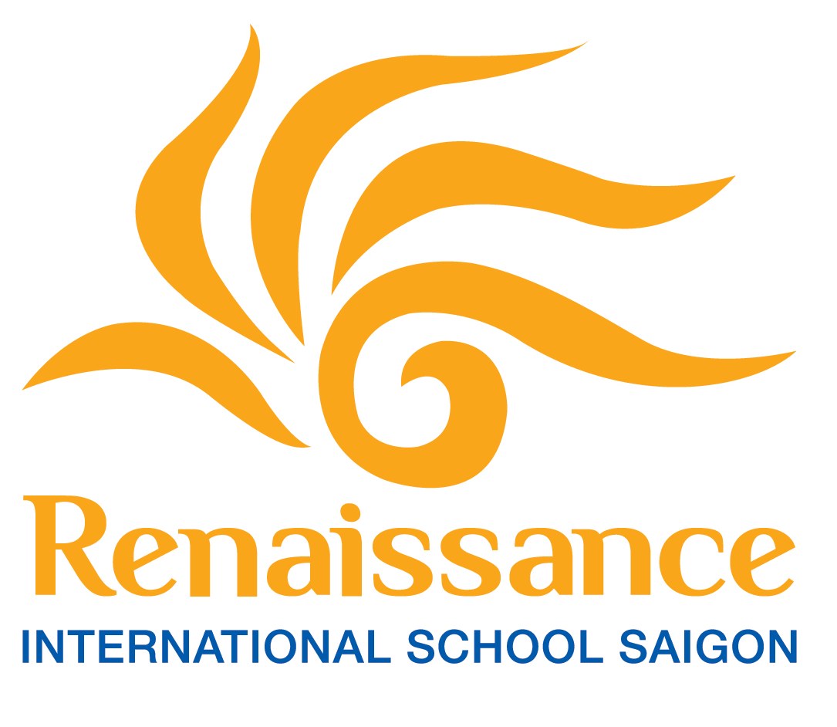
JOB DESCRIPTION
LOCATION | Renaissance International School, Saigon
JOB TITLE | MAC (Marketing Admissions Communications) Manager
JOB PURPOSE | The MAC Manager is a strategic leadership role responsible for driving school growth through effective student recruitment and brand management. This role ensures that the school maintains a high-end reputation and delivers an exceptional customer experience to all prospective and current families.
REPORTING TO | Head of School and the COO when appropriate
PACKAGE | Competitive and to be discussed at interview
SAFER RECRUITMENT PRACTICES | Renaissance International School is committed to safeguarding and promoting the welfare of children and applicants must be willing to undergo child protection screening appropriate to the post, including references from previous employers in accordance with our recruitment policy. Where possible, interviews will be conducted in person, and they will explore candidates’ suitability to work with children.  All staff are required to manage effective personal development as part of the school’s commitment to invest in staff as the key resource in the organisation.  - Each individual must ensure that they meet their statutory responsibilities and school policies with regard to Health and Safety, Equal Opportunities and other relevant legislation.  - Hold a current Criminal Background Check or International Police Check or equivalent for the country the applicant is coming from and your home country.  - Any other appropriate duties as allocated by the Head of Section and/or Head of School.
MISSION STATEMENT | School Mission:  As a student-centred, family-focused community, we will guide learners on their journeys towards fulfilling their individual potential, embracing their own independence and internationalism in a safe, supportive, and challenging environment.  - Exceptional Experiences - for us, in every area of school life, for all stakeholders, we contribute to providing the fullest educational and professional experience.  - Outstanding Teachers – the greatest impact on a child’s growth and success comes from the quality and engagement of every teacher. The impact on a child’s learning, support and growth needs to be immediate, positive, and lasting.  - First-class Facilities - for us, we want to see our facilities support our aspirations for a first-class education and professional experience for all.  - Unparalleled Service – in all we do, we focus on giving the highest levels of service for all of our community. getting the little things right.

KEY RESPONSIBILITIES & DUTIES
- Strategic Leadership & Data-Driven Growth
- Work with the Head of School, COO/Corporate MAC Department, and Pedagogical leads to define the MAC strategic direction, including admissions, branding, digital communication, and market research.
- Maintain up-to-date knowledge of the market, competition, and audiences to provide the school with a competitive advantage.
- Keep the MAC team fully informed on the school’s educational offer, student achievements, and competitor landscape to ensure accurate and compelling communication to prospective parents.
- Manage the MAC budget to ensure excellent results and high ROI.
- Use data and insights to provide accurate enrollment forecasts and identify growth opportunities, such as new programs or additional capacity.
- Admissions & Family Experience Journey
- Lead the Admissions team to deliver a market-leading, highly personalized "Family Experience Journey" at every touchpoint.
- Maximize lead generation and conversion rates through effective qualification processes and efficient application turnaround times.
- Ensure re-enrollments are maximized by offering a relevant and engaging experience for current families.
- Oversee the parent onboarding process to ensure a seamless transition from admission to school life.
- Actively involve parents, students, and academic staff in the enrollment journey through school tours and student ambassador programs.
- Marketing, Brand & Communications
- Act as Brand Custodian, ensuring the school’s value proposition, USP, and brand guidelines are consistently implemented across all physical and digital channels.
- Build and execute an annual marketing plan with clear campaign objectives and timelines aligned with the school’s strategic direction.
- Assure a friendly and fluid digital experience across owned, earned, and paid media.
- Support and amplify Word of Mouth (WoM) and referral programs to build a strong parent ambassador network.
- Support management in communication decisions during crisis situations or sensitive issues.
- Develop a press and media strategy to manage the school’s public profile and media engagement to protect and enhance its reputation.
- Community Engagement & Cross-school Collaboration
- Develop external networks and maintain strong partnership relationships with corporates, including but not limited to relocation agents, corporate clients, embassies, and key community organizations…
- Develop and sustain strong relationships with the school’s alumni community to support enrolment growth, brand advocacy, and long-term institutional reputation
- Cross-School Collaboration: Contribute to wider initiatives by sharing best practices and supporting regional marketing and admissions efforts to drive group growth.
- Work with cross-school teams to ensure alignment with group strategies and reporting standards.
- Any other tasks as required by the line manager

PERSON SPECIFICATIONS

Experience/ Knowledge
- BA/Master’s Degree in Marketing, Communications, or Business. |  | Essential
- 7+ years of experience in sales, marketing, or admissions management, ideally in international education. |  | Highly Desirable
- Proven track record of meeting enrollment targets and driving strategic growth. |  | Essential
- Deep understanding of the international school market, competitor landscape and data integrity. |  | Essential

Skills
- Customer Experience Leadership: Ability to deliver a personalized parent journey. |  | Essential
- Strategic Thinking: Ability to analyze market trends and adjust recruitment strategies. |  | Essential
- Communication Excellence: Fluent in English (written/oral); Vietnamese is a strong advantage. |  | Essential
- Influencing Skills: Ability to build rapport with high-net-worth families and diverse stakeholders. |  | Essential

Personal Attributes
- Result-oriented with a mindset focused on quality relationships. |  | Essential
- Entrepreneurial spirit: agile, innovative, and seeking continuous improvement. |  | Essential
- Resilience and serenity under pressure in a fast-paced environment. |  | Essential

(*) Flexibility to meet the demands and time-commitments of a middle leadership post.

